

**Resources and Information for Primary Care Providers   
(and their patients)**

**Prepared by: CanREACH**

**A small thank you to you for taking this training!!!**

 **Email:** [**canreach@ahs.ca**](mailto:canreach@ahs.ca)

**Table of Contents**

Frequently Used Websites for Physicians pg. 3  
Assessment Extras pg. 4-5  
Children’s Global Assessment Scale (Function) pg. 6  
Assessing for Adverse Childhood Experiences (ACEs) pg. 7  
ACEs and Trauma Informed Care in Primary Care – Tip Sheet pg. 8  
Patient Handout specific to ACEs in Primary Care pg. 9  
Engagement Approaches for Primary Care - Summary pg. 10  
Psychoeducation and Psychosocial Interventions in Primary Care pg. 11  
SSRI Medications in Primary Care pg. 12  
Primary Care Provider Communication with Schools - Samples pg. 13  
Substance Use Assessment in Primary Care (CRAFFT) pg. 14  
Promoting Healthy Sleep Practices – Patient Handout pg. 15  
Promoting Relaxation – Patient Handout pg. 16  
Mood Enhancing Prescription – Patient Handout pg. 17  
Mood Enhancing Prescription – Caregiver Handout pg. 18  
Non-Suicidal Self-Injury – Parent Information pg. 19  
Safety Planning and Self-Harming Behaviors pg. 20  
Community Counselling Services pg. 21  
Mobile Applications for Patients (self-help) pg. 22  
Support and Education for Families (by topic) pg. 23

**Web-Based Resources – Frequently Used Websites for Physicians** *We recommend visiting each site and bookmarking it to the computers you use for easy access!*

🡪 CanREACH Website   
*Contains the medication cards, resources, added extra training modules, and so much more (see resources)*https://wp.hmhc.ca/canreach/

🡪 PROJECT TEACH – Child and Adolescent Psychiatry for Primary Care (US based)  
*This is an excellent website for finding the rating scales we review during CanREACH*  
https://projectteachny.org/rating-scales/

🡪 Collaborative Mental Health Care   
*This Canadian based website has fantastic “toolkits” organized by diagnostic area*  
<http://www.shared-care.ca/toolkits>

🡪GLAD-PC and T-MAY  
*Guidelines shared during the CanREACH training, you can access by the CanREACH Website, or directly as follows*GLAD-PC: <http://glad-pc.org/> T-MAY: <http://www.t-may.org/>

🡪 Child Mental Health   
*Website with electronic rating scales, a physician area with compiled toolkits, and a patient area with resources*<https://childmentalhealth.ca/>   
  
🡪CADDRA  
*Canadian ADHD Resources Alliance has resources, rating forms, and practice guidelines*  
<http://www.caddra.ca/>

🡪 CAMESA   
*CAMESA guidelines provide parents and doctors information about side effects of antipsychotic drugs in children.*  
<http://camesaguideline.org/>

🡪 KELTY Mental Health, BC Mental Health  
*Medication Overviews that can be saved/printed as PDF re: various medications and classifications*  
<http://keltymentalhealth.ca/treatment/medications>

🡪 Choosing Wisely Canada  
*Guidelines and recommendations to ensure high-quality care covering all areas of medicine. Psychiatry Specific:*   
<http://www.choosingwiselycanada.org/recommendations/psychiatry/>

**Assessment: Mental Health Screenings**

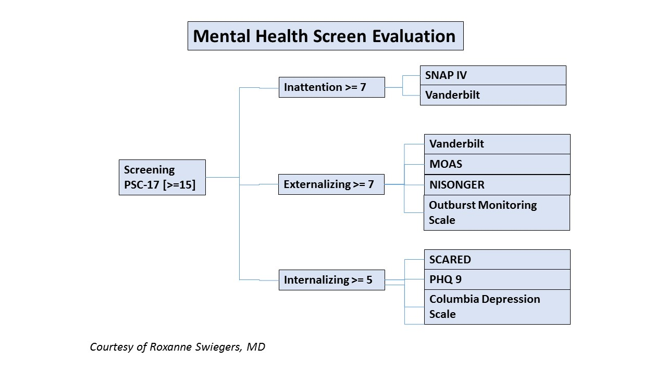

**Assessing Impairment – “Spheres of Functioning”**Is there a sense that emotions, behaviors and/or inattention is affecting:



Extra - Curricular

Home Environment

Friendships

School or Learning

Self Esteem

**Assessing Young People “tips”**

|  |  |  |  |
| --- | --- | --- | --- |
|  | | “Do” | “Don’t” |
| Setting | Interview children alone, without parents | | See children with parents only |
| Introduction | Review confidentiality.  Tell them you want to learn more about them. | | Assume comfort/discomfort and knowledge  Tell them you want to ask questions |
| Participation | Encourage non-distracting activity / fidget toys | | Demand attention or comment on hyperactivity |
| Discussion | Show interest and offer positive feedback  Prioritize establishing good rapport Model comfort and openness Open questions and provide options | | Challenge their answers or focus on negatives Push your agenda Avoid or assume difficult / sensitive topics  Closed, biased or leading questions |
| Interpretation | Check on your and their understanding | | Assume understanding |

|  |
| --- |
| **Example Questions** |
| Who lives at home with you? What are the rules like at home? How do you get along with your parents / siblings? What things do you do together? What happens when there is conflict? Is there anything you would like to change about your family? |
| Are you in school? What are you good at in school? What is hard for you? What grades do you get? How do you get along with people at school? What do you want to do when you finish school? |
| What do you do for fun? What things do you do with friends? Are you in any sports or activities? What do you do with your free time? Tell me about your hobbies or interests? |
| Many young people experiment with drugs, alcohol, or cigarettes. Have you or your friends ever tried them? What have you tried? |
| Are you / have you been involved in a relationship? How was that for you? Have you been sexually active? How do you see yourself in terms of sexual preference, i.e. gay, straight, or bisexual? |

**Assessment using HEADSS**

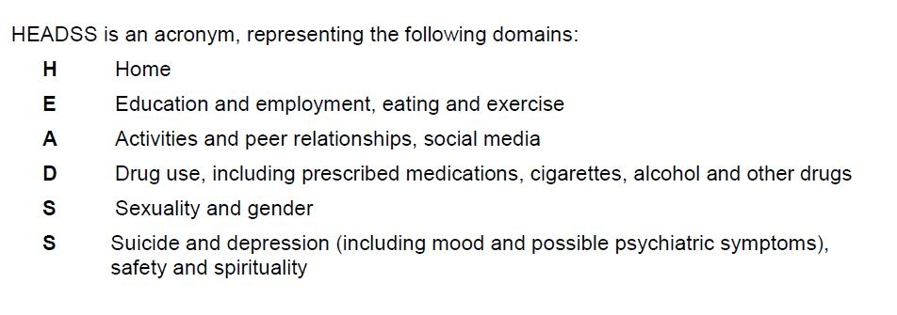

**Assessing Symptoms: C** Characteristics **O** Onset **L** Location **D** Duration **E** Exacerbation **R** Relief

**Assessment / Conceptualization Chart**

|  |  |  |  |  |  |  |  |  |  |  |  |  |  |  |
| --- | --- | --- | --- | --- | --- | --- | --- | --- | --- | --- | --- | --- | --- | --- |
|  | **INDIVIDUAL FACTORS** | | |  |  |  | |  |  |  | **SYSTEMIC FACTORS** | | | |
|  | **BIOLOGICAL** | **BEHAVIORAL** | **COGNITIVE** | | | | **FAMILY** | | | | | **SCHOOL** | **SOCIAL** |
| **PREDISPOSING** | -Family hx -Genetics -Pre/post natal  -Development | - Hx of reinforcement and punishment - Conditioning | -Dysfunctional assumptions and beliefs - Illness or injury | | | | -Structure -History -Availability and communication -Modelling | | | | | -IQ -Learning difficulties -Environment | -Availability -Gender -Social Skills -Cultural |
| **PRECIPITATING** | -Trauma -Toxins -Adverse Events (ACEs) | -Loss -Adverse Events (ACEs) | -Negative Automatic thoughts | | | | -Individual or family crisis -Adverse Events (ACEs) | | | | | -Change -Failure -Social | - Change or Loss of social support - ACEs |
| **PERPETUATING** | -Substance use -Chronic illness  -Disabilities | -Family/social (negative, -) reinforcement | -Lack of insight -Patterns  -Primitive coping | | | | -Stress, conflict -Loss, change -Skill and ability | | | | | -Undiagnosed difficulty  -Relationship | -Individual and environmental factors |
| **PROTECTIVE** | -Good health -Absence of family hx  -Temperament | -Absence of ACEs - Variety and availability of + reinforcements | -Capacity and insight -Corrective actions | | | | -Flexible -Adaptable -Available | | | | | -Satisfaction -Achievement -Quality -IQ | -Temperament -Ability -Access |

**Children’s Global Assessment Scale**

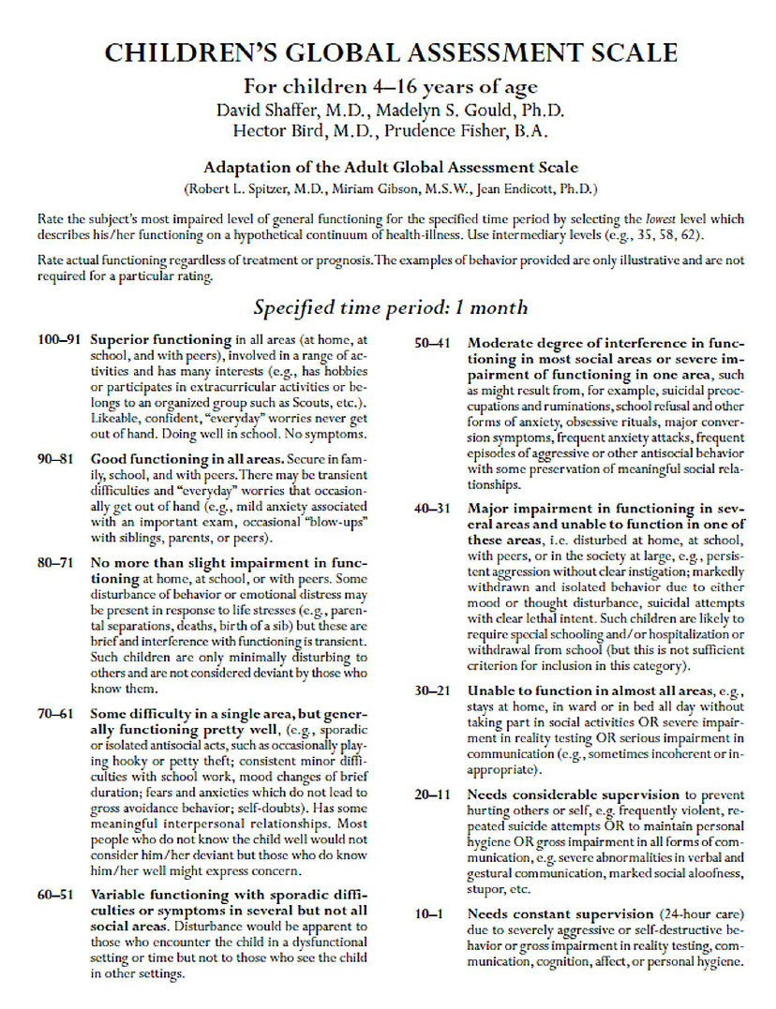

**Assessing For Adverse Childhood Experiences (ACEs)** *Adapted from* [*http://www.albertafamilywellness.org/assets/Resources/CAAMHPP-ACE-TIC-Resource-Guide-Nov-2016.pdf*](http://www.albertafamilywellness.org/assets/Resources/CAAMHPP-ACE-TIC-Resource-Guide-Nov-2016.pdf)

**Finding Your ACE Score**

|  |  |  |  |
| --- | --- | --- | --- |
|  | **While you were growing up, during your first 18 years of life:** | **Yes** | **No** |
| 1. | Did a parent or other adult in the household **often or very often**…  Swear at you, insult you, put you down, or humiliate you? **or**  Act in a way that made you afraid that you might be physically hurt? |  |  |
| 2. | Did a parent or other adult in the household **often or very often**…  Push, grab, slap, or throw something at you? **or**  Everhit you so hard that you had marks or were injured? |  |  |
| 3. | Did an adult or person at least 5 years older than you **ever**…  Touch or fondle you or have you touch their body in a sexual way? **or**  Attempt or actually have oral, anal, or vaginal intercourse with you? |  |  |
| 4. | Did you **often or very often** feel that …  No one in your family loved you or thought you were important or special? **or**  Your family didn’t look out for each other, feel close to each other, or support each other? |  |  |
| 5. | Did you **often or very often** feel that …  You didn’t have enough to eat, had to wear dirty clothes, and had no one to protect you? **or**  Your parents were too drunk or high to take care of you or take you to the doctor if you needed it? |  |  |
| 6. | Were your parents **ever** separated or divorced? |  |  |
| 7. | Was a family member:  **Often or very often** pushed, grabbed, slapped, or had something thrown at him/her? **or**  **Sometimes, often, or very often** kicked, bitten, hit with a fist, or hit with something hard? **or**  **Ever** repeatedly hit at least a few minutes or threatened with a gun or knife? |  |  |
| 8. | Did you live with anyone who was a problem drinker or alcoholic or who used street drugs? |  |  |
| 9. | Was a household member depressed or mentally ill, or did a household member attempt suicide? |  |  |
| 10. | Did a household member go to prison? |  |  |
|  | **TOTAL ACE SCORE**  Each answer of ‘Yes’ is scored as a ‘1’.  Count the total number of ‘Yes’ responses. |  |  |

**Your ACE Score is: _________**

**Incorporating ACEs and Trauma Informed Care (TIC) in Primary Care   
   
WHY ASK?** While also being important health information, asking about ACES connects the dots   
 and decreases the burden of the experience.   
  
**HOW ASK?** Use the ACEs questionnaire and build it in to your practice.   
 Shift the question from “what’s wrong with you” to **“WHAT HAPPENED TO YOU?”** Example Script to introduce it and why it matters: “*Your emotional health is as important as your   
 physical health. We are asking all of our patients these questions as they can be   
 important pieces of the overall puzzle that is your health.”* TIPS: -Remember this is a History Taking for risk factors that affect current and future health.  
  
**THEN WHAT?**  If ACEs uncovered, then ask: **“HOW HAS THAT IMPACTED YOU?”**  
   
 Example Script to respond to the ACE score: *“I see that you have an ACE score of X. You have   
 been through some difficult stuff. How has this / have these experiences impacted you?*   
  
 TIPS: -Don’t ask for details of the trauma, patients will put it into context when you listen.  
 -Remember that you cannot FIX what happened. Highlight strengths and resiliency.  
 -Inquire about the impact and respond with compassion, empathy and validation.

The IMPACT directs interventions you offer (i.e., parent training, therapy, nothing).   
 For instance, low score and no impact, you might enhance protective factors/resiliency.  
 Score over three and/or any impact, offer resources for intervention / treatment options.   
  
 Example Script to manage the ACE score: *“Your body and brain were busy navigating these   
 challenges while you were growing up. There may be some strategies or supports that   
 might be helpful to you now”.* TIPS: -Be optimistic that high ACEs are not deterministic.  
 -Highlight and offer useful resources to boost skills, abilities and supports pending needs.  
 -Matching the right resource to the right need is key (i.e., basic needs require tangible   
 resources while psychological needs require services).   
 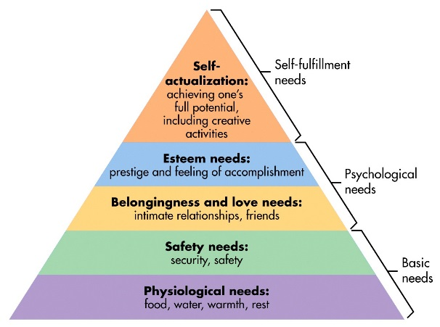

**Adverse Childhood Experiences (ACEs) and Their Effects on Your Health**  
We have asked you about ACEs as part of your routine, comprehensive care. We ask all of our patients these questions. Facing adversity can be a challenge, and can also build resiliency and coping skills. We know ACEs are common, can affect how the brain develops, and may increase a person’s risk of having physical, [mental or emotional](https://readyornotalberta.ca/ready/healthy-mind-and-body/mental-health-and-stress/) health problems throughout their lifespan. But remember, this is a risk factor, and it’s never too late to decrease your risk! Here are some resources and strategies for you to consider.



“The Big Four”

1. Sleep 7 or more hours each night.
2. Eat a well-balanced diet, and avoid processed foods.
3. Exercise a minimum of 30 minutes 3 times per week.
4. Spend time with good, supportive friends.

Although “The Big Four” lifestyle factors may seem simple, they are the foundation for healthy emotional and physical health.

Source: <http://www.drdawnkingston.com>

**Online and Apps & Resources:**

Prevent and manage symptoms of anxiety and depression: www.moodgym.com.au  
 www.anxietybc.com  
 www.cci.health.wa.gov.au  
 www.ecouch.anu.edu.au  
Meditation and mindfulness:   
 www.headspace.com

[www.smilingmind.com.au](http://www.smilingmind.com.au)  
 [www.breathingroom.me/](http://www.breathingroom.me/)

Workbook to print  
 www.cci.health.wa.gov.au

https://**smilingmind**.com.au

**Resources to help learn more about ACEs**

**Alberta Family Wellness Initiative**   
 *Videos on the impact of ACEs on brain development*

<http://www.albertafamilywellness.org/building-better-brains>

**Centre for Disease Control**

<http://www.cdc.gov/violenceprevention/acestudy/index.html>

**ACES Too High**  
 [www.acestoohigh.com](http://www.acestoohigh.com)   
  
**Alberta Health Services Ready or Not website**

[https://readyornotalberta.ca/ready/healthy-mind-and- body/adverse-personal-experiences/#2640](https://readyornotalberta.ca/ready/healthy-mind-and-%20%20body/adverse-personal-experiences/#2640)

**Parenting Resources** – [www.cfpcn.ca/](http://www.cfpcn.ca/) Under resources

+Call  
  
Family Physician  
Book an appointment to discuss possible management options and PCN support links

Access Mental Health  
With over 1700 community programs, Access Mental Health can connect you with resources specific to your needs (parenting, therapy, mental health support, and more).  
403-943-1500 in Calgary  
1-877-652-4700 outside of Calgary

**Useful Approaches for Assessment & Engagement in Primary Care**

🡪 Motivational Interviewing – OARS Strategy

|  |  |  |  |
| --- | --- | --- | --- |
| **o** | **A** | **R** | **S** |
| Open-ended Questions | Affirmative Statements | Reflections | Summary Statements |
| - Ask open-ended questions that encourage response to engage in 2-way dialogue - Goal to understand barriers and expectations | - Recognize the patient’s strengths, successes, and efforts to change - Goal is to promote a collaborative relationship | - Use reflective listening by responding with thoughtful paraphrasing - Goal is to ensure patient is heard and validated | - Use statements to recount and clarify the patient’s statements.  - Goal is to identify points/goals to act on |

🡪 Motivational Interviewing – LEEAP Strategy

|  |  |  |  |  |
| --- | --- | --- | --- | --- |
| **L** | **E** | **E** | **A** | **P** |
| Listen | Empathy | Educate | Agree | Partner and Plan |
| Be curious and use open-ended questions to ask about the client’s view. Look for non-verbal feeling transmitted along with words. | Seek to understand what it has been like for your client (i.e., shame, stigma, difficulty). | Offer psychoeducation and ensure awareness of the child’s basic needs (to feel loved, important, and accepted). | Exchange information and share ideas of what might work to work towards finding areas you can agree on. | Through shared decision-making, offer support and interventions that can be monitored and adjusted. |

🡪 Strengths-Based Approach

|  |  |
| --- | --- |
| Identify Strengths | Doing so early on encourages relationship, allows patient to feel accepted and can be built on later. |
| Look for Successes | Look for examples of past difficulties the patient has successfully overcome. The ability to adapt and overcome is resiliency, and is highly protective. |
| Consider the Setting | Create a trusting, safe, non-judgemental setting that communicates mutual respect. |
| Use Praise and Reflective Listening | Find areas to praise; often kids hear a lot of negative, particularly those struggling most. Allow the patient time to confirm and expand on their thoughts. |
| Share Concerns | It is acceptable to gentle challenge your patient by voicing your concern for them. |

🡪 Trauma-Informed Approach

|  |  |
| --- | --- |
| Traditional | Trauma-Informed Care Approach |
| Ideology: WHAT’S WRONG WITH YOU Symptom Focused, Bio-Medical Labels & Pathology Didactic People need fixing first | Ideology: WHAT’S HAPPENED TO YOU Whole person, Bio-Psycho-Social Behaviour as Communication Participatory People need safety/support first |

**Psychoeducation and Psychosocial Interventions in Primary Care**

**PROMOTE**  
- Healthy lifestyle (sleep, nutrition, activity, engagement)

**DEMYSTIFY**  
- Dispel myths and educate with accurate information

**DISCOVER**  
- What does the patient/family know about the diagnosis

**RESOURCES**  
- For further information and services

**INFORM**  
- Evidence-based treatments exist with positive outcomes

**EMPATHIZE**  
- Acknowledge feelings of grief, fear, frustration

Psychoeducation is an important part of the working relationship between patient and care provider, and is a necessary part of any diagnosis.

Psychosocial interventions are critical in treating any diagnosis. While there is a role for medication, remember that medications cannot “fix” or “replace” other necessary components to treatment. There are many psycho-social areas to consider when offering comprehensive assessment and treatment and a multi-modal approach improves not only the core diagnosis symptoms, but also the overall quality of life by improving the resultant functional impairments.

**SSRI Medication in Primary Care***Adapted from the GLAD-PC* [*http://glad-pc.org/*](http://glad-pc.org/)

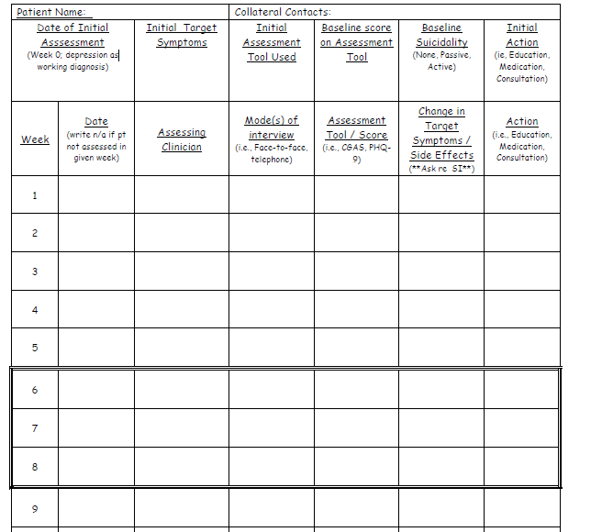

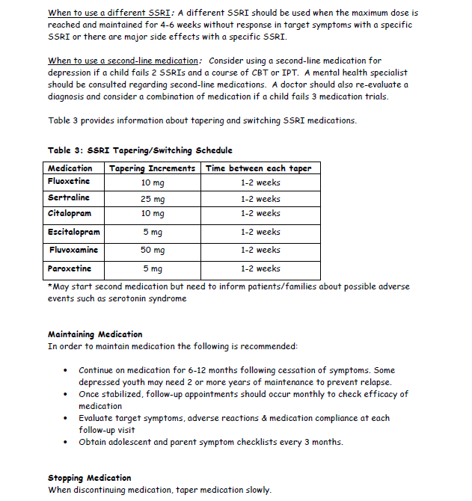

**Primary Care Provider Communication with Schools - Samples**Adapted from CADDRA

Name of the School: __________________________________ Date: ____________________  
Name of the Teacher(s): __________________________________  
Name of the Student: __________________________________ DOB: ____________________  
  
Hello,   
Your student, _________________________________________, is presently under medical evaluation. To assist with this process, his/her doctor would appreciate your observations on his/her functioning in class. Your feedback will be important in providing knowledge of the student's functioning in the school setting.

As his/her teacher, you are a key part of his/her learning process. We thank you for your input and your assistance in better assessing the needs of this student. The objectives of these forms are to reach an accurate diagnosis and offer interventions and therapeutic solutions that will be individualized for this student.  
If you are unsure of your response, go with your first instinct. Do not leave any items blank.  
  
Questionnaires Requested to be completed: ______________________________________________________  
  
You can return this information to my office, confidentially, at: _______________________________________  
  
Thank you kindly for your cooperation,  
__________________________________

Name of the School: __________________________________ Date: ____________________  
Name of the Student: __________________________________ DOB: ____________________  
  
**Re: Request for psychoeducational testing // Request for academic accommodations and support**

With the permission of ____________________, I am writing to request psychoeducational testing regarding the possibility of a learning problem concurrent with psychiatric concerns I am addressing with your student.   
  
With the permission of _________________ I am writing to discuss possible issues of school support and accommodation arising from my recent assessment and concurrent with the diagnosis of ___________________.

I would be pleased to discuss this matter more fully with the appropriate school representative and with the individual who will do the assessment.   
I can be reached at: _______________________________

I look forward to hearing from you soon.   
Sincerely;   
___________________________

**Substance Use Assessment in Primary Care**

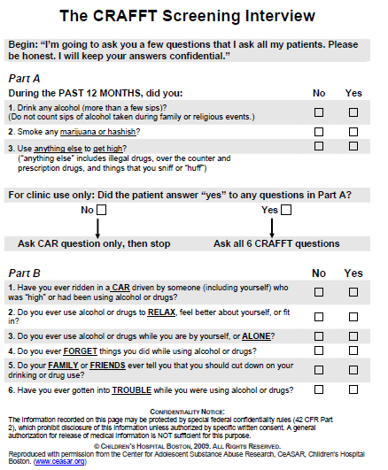

**Promoting Healthy Sleep Practices** 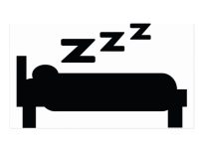 PATIENT HANDOUT

Sleep is important to your physical and mental health. It allows your mind to digest and make sense of the day’s events. It prepares your brain for learning new things the next day. During sleep your brain even cleans itself! Simply put, sleep is essential for life and getting the proper amount of sleep helps us cope better with whatever life brings our way. Getting enough sleep is essential for your emotional health. You may start to feel out of sorts and like you are not yourself if you’re not sleeping well. Noises can seem louder, and colours too bright; small irritations feel like big problems, and even thinking can become a chore. It can get harder to solve problems and you may experience more aches and pains, less energy, and less interest in life. The less you sleep, the more anxious you can become about getting enough sleep, and this might make it even harder to fall asleep. You can end up in a vicious cycle – at the mercy of your over-active mind, feeling unwell, and feeling out of control. But there are things you can do to help break that cycle! Here are a few tested and true strategies that can help!!

|  |  |
| --- | --- |
| **YOU CAN CONTROL WHAT YOU EAT AND DRINK** FOOD: Don’t eat too much food too close to bed time, but also, don’t go to bed hungry. A light pre-bed snack can be good, especially one with milk in it.   CAFFEINE: Caffeine is found in coffee, tea, energy drinks, soda, cocoa, some over-the-counter medications. In general caffeine should be avoided within 8 hours of sleep.  NICOTINE – While it’s not a good idea to smoke because of the harmful health effects anyway, nicotine has a stimulating effect on the brain.   ALCOHOL – Alcohol can interfere with sleep patterns and should be avoided within 4 hours of going to sleep. | **YOU CAN CONTROL YOUR SLEEP ENVIRONMENT**  Make your bedroom a good place for sleeping – low noise, dark and comfortable, with a cooler temperature.   Use your bed for sleep only; do not use the bed for homework, talking on the phone, watching TV etc. This helps your brain to link being in the bed with sleep.  Keep electronic gadgets out of the bedroom. Remove things like phones, computers, and any other screens from the bedroom at bedtime.   Avoid sleeping in other places (i.e., couch, car), making the regular use of the bed in the bedroom your consistent place of sleep. |
| **YOU CAN CONTROL WHAT YOU DO DURING THE DAY AND BEFORE BED**  Get at least 30 minutes of exercise each day, but avoid vigorous exercise prior to bedtime.  Have a regular set and enforced bedtime! This sets your body’s inner clock for sleep.   Have a pre-bedtime routine that calms you and prepares you for sleep. This should not include looking at bright screens and electronic devices should be a no-go zone for the last 30-minutes at minimum before bed  Avoid napping.  Increase light exposure in the morning. | **YOU CAN CONTROL WHAT YOU DO WHILE YOU’RE FALLING ASLEEP**  Reduce cognitive and emotional stimulation before bedtime.  Keep a pen and paper by the bed; if something is nagging you jot it down for the next day, which may help your mind to be freer to relax.   Incorporate relaxation / calming activities in to the bedtime routine (i.e., warm bath, relaxation imagery, deep breathing, and muscle relaxation).  Do not look at the clock – place it somewhere you cannot easily see from the bed. |

**Promoting Relaxation**

[](https://www.bing.com/images/search?view=detailV2&ccid=eq8OgeHN&id=44D499C597A8B044C281CB6F9BE14C3BFD3A34E4&thid=OIP.eq8OgeHNfHnwlVWosYzULwHaEK&mediaurl=http://themmashow.info/wp-content/uploads/2015/12/relaxation-banner.jpg&exph=520&expw=924&q=relaxation&simid=608046867421267095&selectedIndex=8) PATIENT HANDOUT

While relaxing may seem like a pretty easy thing to do, a lot of people have difficulty actually getting themselves to do it regularly and successfully. Learning relaxation involves figuring out what is going to give you the best chances of success – otherwise your probably won’t keep trying to do it. Find a quiet, safe, comfortable place and remember to practice often. Here are three ways to try.

**Progressive Muscle Relaxation:**   
Start by taking three deep breaths in and out. Clench your fists gently and hold them for 10 seconds and then let go. Rest for 20 seconds and use relaxing self-talk. Tighten your biceps by bending your arms and pulling towards your shoulders (like Popeye!), hold for 10 seconds and release. Tighten your triceps by straightening your arms and locking your elbows, hold, hold, hold, and release. Raise your eyebrows as high as you can, hold it, and relax. Now shut your eyes tightly, hold it, and relax. Open your mouth as widely as you can, hold it for 10 seconds, and relax. Lean your head gently towards your back to tighten the muscles in the back of your neck, hold for five seconds, and now relax. Raise up your shoulders to your ears like a shrug, hold, hold, hold, and release. Deep Breath.   
Push your shoulders back towards each other, pinching the shoulder blades together, hold it, hold it, and release. Take a breath. Tighten your stomach muscles, squeeze, hold and release. Now, arch your lower back up, hold it, hold longer, and release. Tighten your buttocks, really squeeze them, hold for 10 seconds, and relax. Tighten the muscles in your hips and thighs, hold for 10 seconds, and release. Take a deep breath. Now, tighten your shin muscles by pulling your toes towards you, hold, and relax. Tighten your calm muscles by doing the opposite, point your toes down, as hard as you can, hold it, and relax. Take a deep breath, and scan your body, anywhere you feel tension still? Go back over your muscle groups and repeat the exercises in areas that remain tense. Take a moment to feel your body all relaxed and notice how it feels.

**Imagination / Visualization:**Imagining exercises are used in different ways, but the primary goal is to shift your focus from the stresses of the outside world to a safe place where your mind and body are free to relax. Start with a deep breath, now close your eyes and imagine yourself in a peaceful, safe place – anywhere that appeals to you. It can be real or imaginary. Focus on the scene and all the details in the image. Create the entire scene in your mind. Imagine yourself there. Now, try and use all your senses…what do you see? What do you hear? What do you smell? What do you feel? What do you taste?

**Deep Breathing:**One of the most important factors in learning to relax is finding ways to control your breathing. Here are a few ways to try:  
Abdominal breathing is a technique that focuses on using your diaphragm to make sure that your lungs are fully expanding, and that you are not just using the top part of your lungs to breathe. Put one hand on your upper chest and the other on your abdomen. Breathe in deeply. Which one moved? Now take several slow, deep breaths and focus on the breath going in to your belly. Be sure that your lower hand moves out as that muscle below your lungs, your diaphragm, moves out and expands.  
Box-Breathing involves breathing in a controlled manner, in and out slowly, and maintaining a pattern to the breathing. This pattern involves breathing in slowly for a count of four, holding your breath in for a count of four, slowly breathing out for a count of four, and then holding your breath our for a count of four. To help you can imagine the four sides of a box.

**Mood Enhancing Prescription Patient Handout**The Mood Enhancing Prescription is a useful and time efficient tool that can be used to help the young person identify and plan their daily activities. [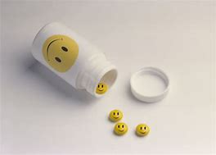](https://www.bing.com/images/search?view=detailV2&ccid=q0KURCbL&id=9045D135580E2B9D5EAAEBECA370E98389EA38FA&thid=OIP.q0KURCbLuLgTVHaeQVG3FwHaFS&mediaurl=http://4.bp.blogspot.com/-HW2V3ZtHDsM/UGzMloI0HCI/AAAAAAAAA08/GUU71WMJvFs/s1600/happy_pills.jpg&exph=572&expw=800&q=happy+perscription&simid=608044599696425075&selectedIndex=3)

There are many things that you can do to help your mood / anxiety. Sometimes these activities by themselves will help you feel better and sometime additional help (such as psychotherapy or medications) may be needed. For each activity write in your plan (include what you will do, how often and with whom).   
Set SMART Goals (Specific, Measurable, Achievable, Realistic, Time-bound).   
We can check in on this in a future appointment to see how it is going.

|  |  |
| --- | --- |
| ACTIVITY | PLAN (what, how often, and with whom) |
| EXERCISE |  |
| EATING WELL |  |
| SLEEPING WELL |  |
| PROBLEM SOLVING |  |
| BEING SOCIALLY ACTIVE |  |

How Likely are you to follow this? (1-10)  
  
What might get in the way (barriers)?  
  
What solutions can you use to get through barriers?

**Mood Enhancing Prescription Caregiver Handout**

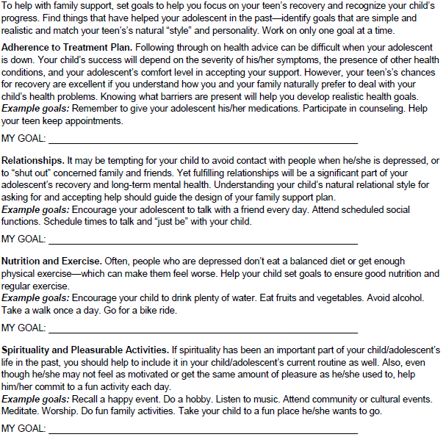

**Non-Suicidal Self-Injury – Parent Information**

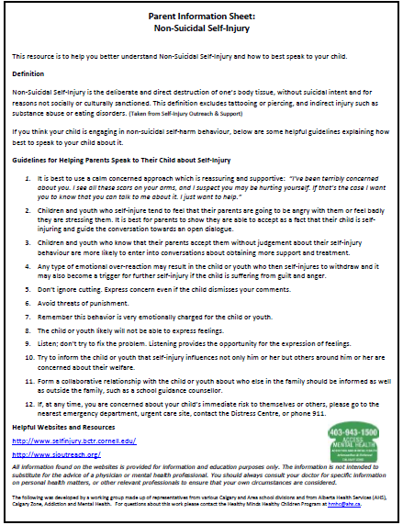

**Safety Planning and Self Harming Behaviors**Information on Creating a Safety Plan: <https://www.verywell.com/suicide-safety-plan-1067524>  
  
Crisis Support Services

|  |  |
| --- | --- |
| Calgary Connect Teen | [Peer support by phone, text, chat or email](http://calgaryconnecteen.com/need-to-talk-urnotalone/)   [http://calgaryconnecteen.com/](%20http://calgaryconnecteen.com/) Phone: 403-264-TEEN (8336) |
| Kids Help Phone | <https://www.kidshelpphone.ca/teens/home/splash.aspx>  Phone: 1-800-668-6868 |
| Distress Center | The Calgary Distress Center will come to you / your child when there is a crisis to assess and respond <http://www.distresscentre.com/>  Phone: 403-266-HELP (4357) |

Alternatives to Self-Harm

🡪Self-Injury Outreach and Support (SIOS) <http://sioutreach.org/>

🡪Coping with Urges <http://sioutreach.org/coping-and-recovery-self-injury/coping-with-urges/>

🡪Self-Injury Recovery Research and Resources SIRRR <http://www.selfinjury.bctr.cornell.edu/>

🡪Distraction Techniques and Alternative Coping Strategies <http://www.selfinjury.bctr.cornell.edu/perch/resources/distraction-techniques-pm-5.pdf>  
 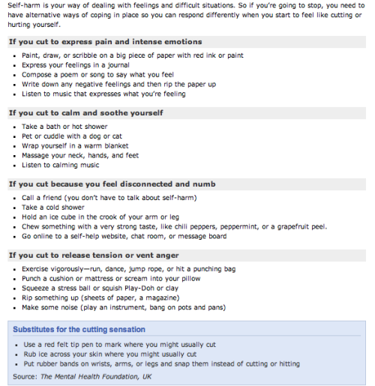

**COMMUNITY COUNSELLING SERVICES** **Free or Low Cost Therapy Services**

**Calgary Counselling Center**   
Suite 1000, 105 12 Avenue SE Phone: 403.691.5991   
Intake telephone lines are open from Monday to Friday 9:00am – 4:00pm at 403-691-5991. An Intake form can be completed over the phone or online at [www.calgarycounselling.com](http://www.calgarycounselling.com/). Offer professional counseling to individuals, couples, and families. The Centre is also an educational facility for interns and residents. Group programs in certain areas are also offered. Cost: fees on a sliding scale based on annual income.

**CARYA (Formerly Calgary Family Services)**  
[www.caryacalgary.ca](http://www.caryacalgary.ca) Main Reception Phone: 403-269-9888 Client Intake Line: 403-205-5244  
Carya offers a continuum of services to actively parenting families of children ages 0-24 years and adults ages 65+. This may encompass issues around mental health, like depression and anxiety, grief and loss, trauma, attachment, relationship challenges, and isolation. Individual counselling and group programs (i.e., CONNECT, BOOST) are offered. Sliding fee scale according to gross household income, however some programs are fully funded and are free of charge to participants. Some programs/groups offered include CONNECT, BOOST (ages 13-16), In-Sync (ages 0-6 and parents play based attachment), Prime Time (ages 0-2 and parents, skill based), Urgent Family Care, Worry Warriors (ages 7-11, 12-15).

**Functioning Families Together (Family Therapy)**   
<http://caryacalgary.ca/our-programs/counselling/functional-family-therapy/>

**Catholic Family Services**   
250, 707 – 10 Avenue SW Intake: 403.233.2360<https://www.cfs-ab.org/>  
To provide counselling and educational outreach services to those experiencing difficulty in any area of their life. Counseling formats include: individual, marital/couples, family. Self-referral by contacting Intake. Sliding scale fees; fee will not be a barrier.  
  
**Calgary Family Therapy Program**   
[www.familytherapy.org](http://www.familytherapy.org) Phone: 403-802-1680  
Offering family therapy services for families with children 18-years or younger. Professional therapists work with families whose children are experiencing emotional or behavioural problems, with the primary goal being to enable these families to develop their own methods of managing the problems more effectively. Families can self-refer, or be referred by community professionals, by phone, fax, mail, or e-mail. Required information for intake includes names, address, phone numbers and a brief description of the problems. There is no cost for this service, and wait times depend on service demands.   
 **Eastside Family Center – Counselling**   
Phone: 403-299-9696 [http://www.woodshomes.ca](http://www.woodshomes.ca/site/PageNavigator/programs/crisis/programs_eastside.html#sthash.GgbjrVXJ.dpuf)  
The Eastside Family Centre offers mental health services for youth, families and individuals experiencing emotional upset that may arise from a variety of situations. Walk-in counselling services are available at no cost and no appointment is necessary. Multidisciplinary teams of professionals, including psychiatric and clinical consultation, are available. The Centre also provides no-cost, legal advice in collaboration with Calgary Legal Guidance.

**Mobile Applications for Patients (self-help)**

**ADDICTION AND MENTAL HEALTH MOBILE APPLICATION DIRECTORY 2017** [**http://www.albertahealthservices.ca/assets/info/res/mhr/if-res-mhr-kt-mobile-app-directory.pdf**](http://www.albertahealthservices.ca/assets/info/res/mhr/if-res-mhr-kt-mobile-app-directory.pdf)



|  |  |
| --- | --- |
| Mind Masters | MindMasters is a research based program that teaches simple and concrete techniques to help children manage stress and frustration, relax and develop a positive perspective. These skills may be incorporated into existing children’s services, such as therapeutic, educational and recreational services, or used by parents at home. <http://www.cheo.on.ca/en/MindMasters>  Mini MindMasters – (under 6) <http://www.cyhneo.ca/mini-mindmasters> MindMasters – (Level 1 Ages 6-9, Level 2 Ages 9-12) <http://www.cyhneo.ca/mindmasters>  MindMasters 2 – (Ages 4-9)  <http://www.cyhneo.ca/mindmasters-2-dha2r> |
| Booster Buddy | This app guides a series of daily quests designed to establish and sustain positive habits like coping skills and self-care. <http://viha.ca/cyf_mental_health/boosterbuddy> |
| Mind Your Mood | The app allows young people to record how they feel each day without drawing unwanted attention from peers. [https://mindyourmind.ca/interactives/mind-your-](https://mindyourmind.ca/interactives/mind-your-mood) [mood](https://mindyourmind.ca/interactives/mind-your-mood) |
| Mind Shift | App designed to help teens and young adults cope with anxiety. Teaches how to relax, develop more helpful ways of thinking, and identify active steps.  <https://www.anxietybc.com/resources/mindshift-app> |
| ToDoIst | Organization in ADHD: <https://en.todoist.com/> |
| Anxiety Coach | Self-help app that addresses fears and worries using CBT strategies. <https://itunes.apple.com/us/app/anxietycoach/id565943257?mt=8> |
| Mood Kit | The skills taught include self-monitoring, identifying and changing unhealthy thought patterns, and engaging in mood-enhancing activities. <https://itunes.apple.com/ca/app/moodkit-mood-improvement-tools/id427064987?mt=8> |
| Breathe 2 Relax | A simple, intuitive app to teach breathing techniques to manage stress. <https://itunes.apple.com/us/app/breathe2relax/id425720246?mt=8> |
| Mood Tools | MoodTools is a self-help app targeting depression. It provides psychoeducation about risk factors and psychosocial approaches to treatment, a depression symptom questionnaire (PHQ-9), a thought diary, a suicide safety plan, and videos such as meditation guides. <http://www.moodtools.org/> |
| Breathing Room | BreathingRoom is an online program for youth and young adults aged 13-24, who want to learn new ways to manage symptoms stress, anxiety and depression <http://breathingroom.me/> |

**Support and Education for Families (by topic)**\*\*\* Information Prescriptions has great information, websites, and readings for families pertaining to many different areas and is organized by topic area:    <http://fcrc.albertahealthservices.ca/health-information/library/information-prescriptions/>

|  |  |
| --- | --- |
| **ACEs** | Websites: - Center for Disease Control - ACES and the ACE study <http://www.cdc.gov/violenceprevention/acestudy/index.html> - ACES too High <https://acestoohigh.com/>  Videos:  - Understanding Toxic Stress and the Brain <http://developingchild.harvard.edu/resources/toxic-stress-derails-healthy-development/>  - Brain Architecture [www.albertafamilywellness.org/resources/video/brain-architecture](http://www.albertafamilywellness.org/resources/video/brain-architecture) |
| **ADHD** | Websites: - CADDRA                  <https://www.caddra.ca/>             - ADHD Families          <http://adhdfamilies.ca/>  - CHADD Website        <http://www.chadd.org/> - “My Child has been diagnosed with ADHD, now what?” from the CDC <https://www.cdc.gov/ncbddd/adhd/treatment.html>  Books: *🡪 “My Brain Needs Glasses”*  and “*My Brain Still Needs Glasses”*  by Annick Vincent 🡪 *“ADD Stole My Car Keys”* by Rick Green and Umesh Jain Videos:  ADHD Child        <http://www.shared-care.ca/vid.aspx?y=rLghxG3mGMM>  ADHD Teen        <http://www.shared-care.ca/vid.aspx?y=rIKMo8VuC_c> |
| **Aggression** | - American Academy of Child and Adolescent Psychiatry - aggression and oppositional behaviors called “A Guide for Families” <http://www.aacap.org/App_Themes/AACAP/docs/resource_centers/odd/odd_resource_center_odd_guide.pdf> - Practical Tips for Families: <http://www.shared-care.ca/files/ODD_Education.pdf>  - Websites, Resources and Books for Families:  <http://www.shared-care.ca/files/Behaviour_Problems_Patient_website_and_books.pdf> |
| **Anxiety** | - Anxiety Canada Website             https://www.anxietycanada.com/ - CBT Guided Sessions Online      <http://www.llttf.com/>  - Websites, Resources and Books for Families:  <http://www.shared-care.ca/files/Anxiety_Resources_Updated_June_2015.pdf> |
| **Depression** | - CBT Self-Help -  Mood Gym       <https://moodgym.anu.edu.au/welcome>  - Workbook   <http://www.shared-care.ca/files/Dealing_with_Depression_dwd_writable.pdf> |
| **Parenting** | - Triple P Positive Parenting Program (free online course) <http://www.triplep.net/glo-en/home/>  - Strongest Families: Online parent coaching management program Toll-free 1-866-470-7111  <http://strongestfamilies.com>  - COMPASS (YWCA) offers in-home support. Referral is required from a professional (i.e., family physician)Phone: 403-263-1550 // 403-294-3664 Fax: 403-262-1743 |